## Validate CRM solutions using PowerApps checker PowerShell module

1. Login to azure portal.
2. After logged in successfully, navigate to Azure Active Directory and select App registrations.

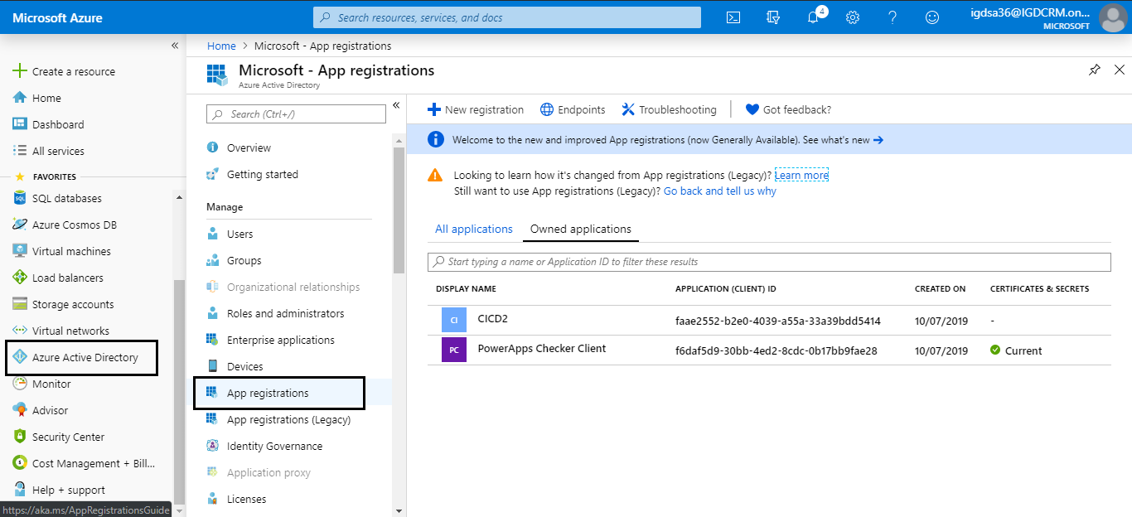

1. Click New registration.

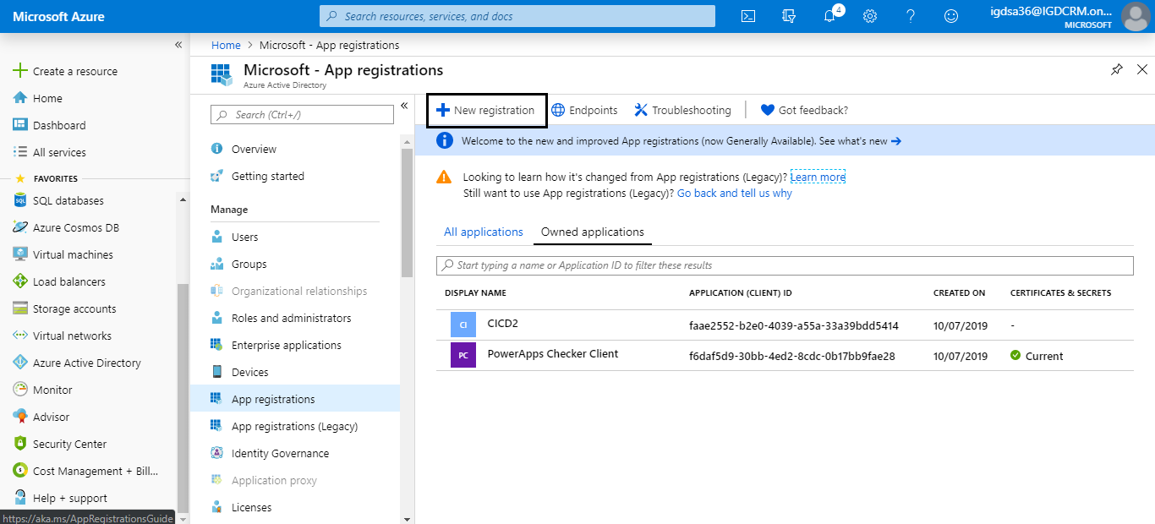

1. Fill Name and in Redirect URI select **Public client (mobile & desktop)** and fill **urn:ietf:wg:oauth:2.0:oob** click register.

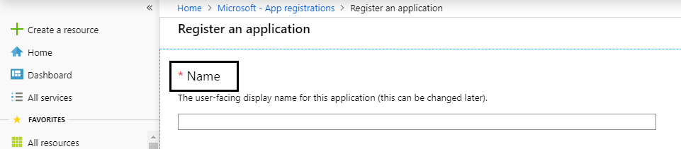

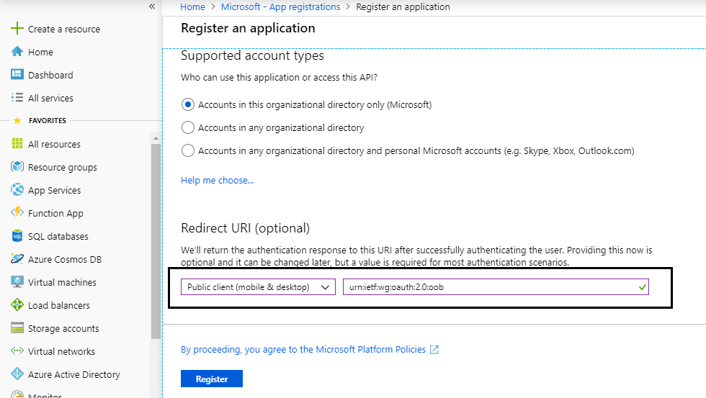

1. After successful register, click API permissions and add a permission for PowerApps advisor.

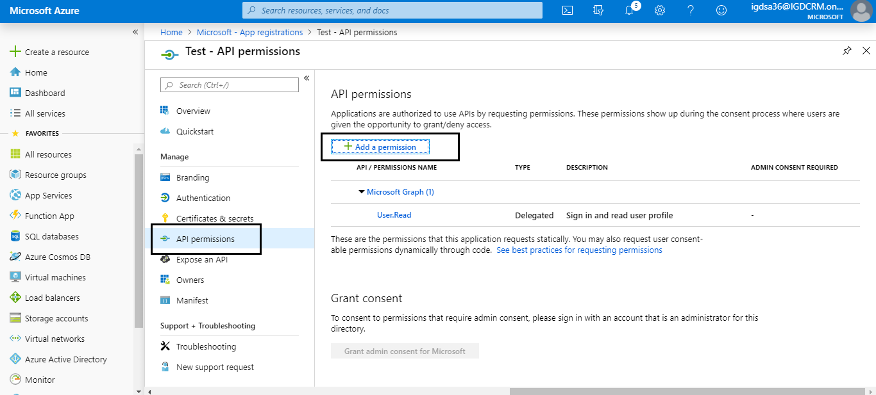

1. In Request API permissions go to APIs my organization uses search for “**powerapps**” and select PowerApps-Advisor.

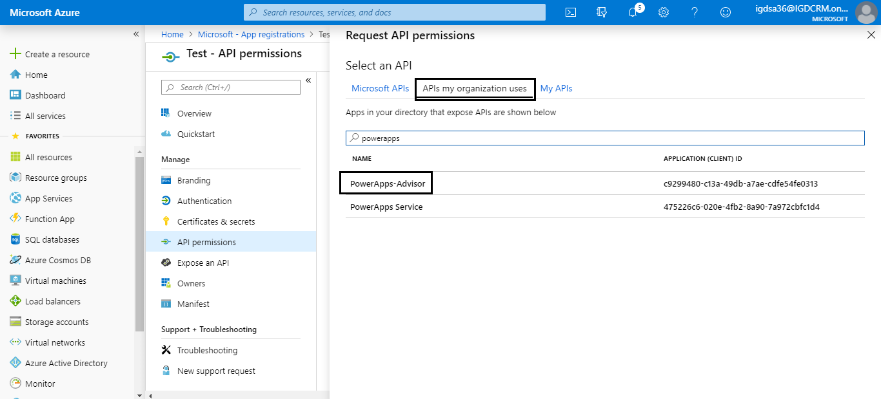

1. In type of permission select **Delegated permissions** and in permission select all and add permission.

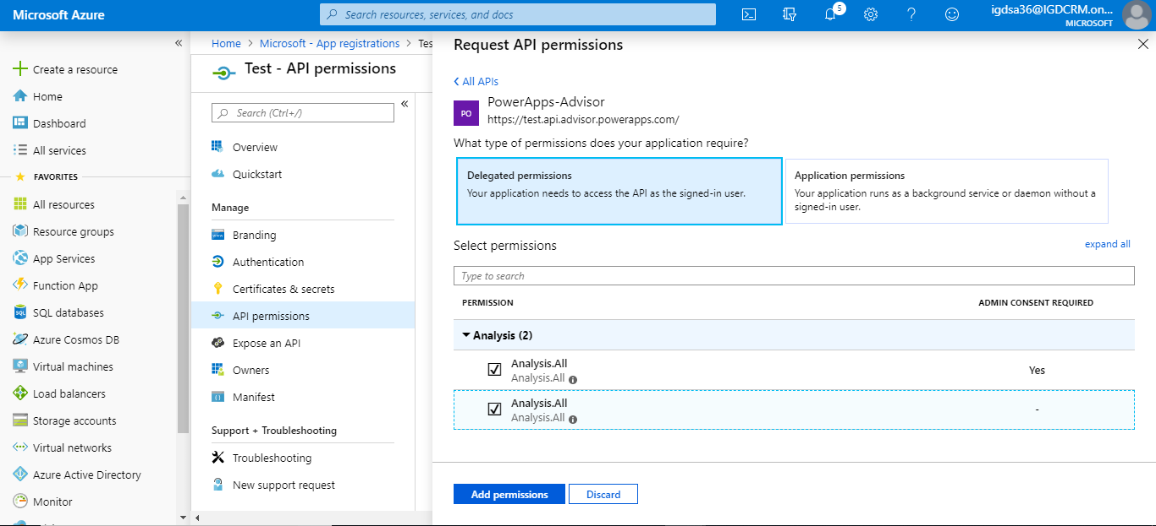

1. Finally, go to Overview and copy client id, tenant id.

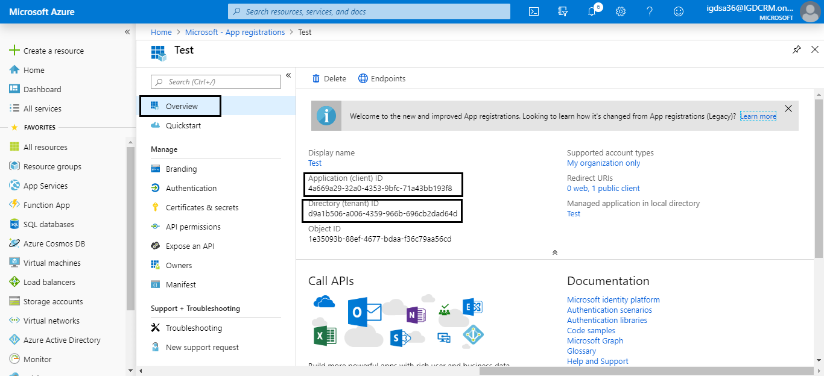

1. Login to CRM and navigate to configuration settings entity.

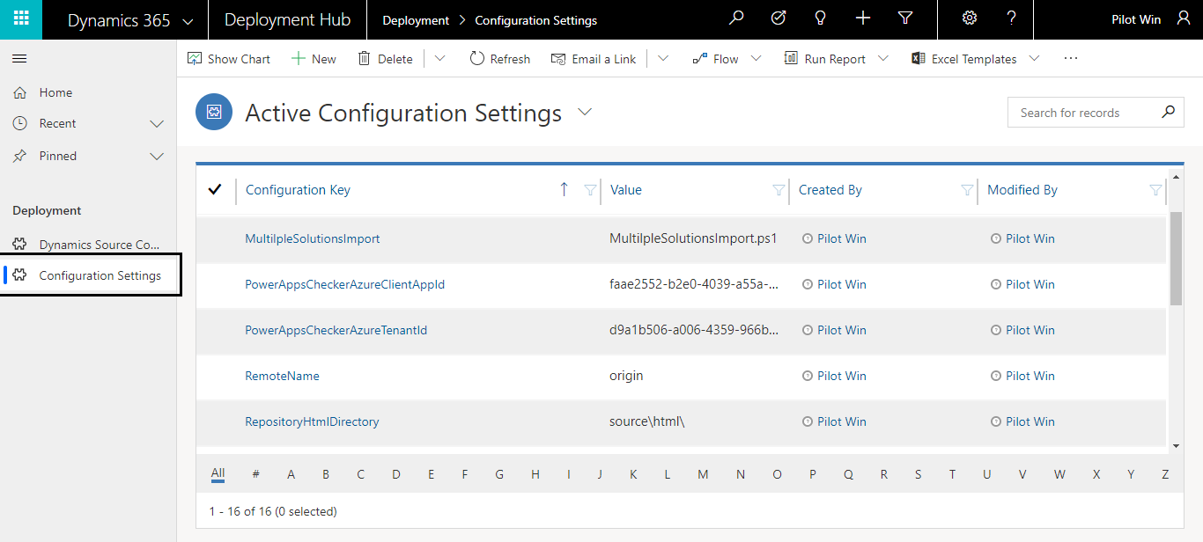

1. Copied client and tenant id should be filled in PowerAppsCheckerAzureClientAppId, PowerAppsCheckerAzureTenantId fields respectively.

